**Fundamentals of programming**

**Lab Manual 3**

***Muhammad Abdullah***

***ME-15 Section A***

***Qalam: 454502***

**Lab Task 1:**

int main()

{

//declaration of number and arrays

int num[10],i;

//using for loops to enter numbers in array

for(i=0;i<10;i++)

{

cout<<"please enter numbers"<<endl;

cin>>num[i];

}

//outputting the numbers in array

cout<<"numbers in the array are:"<<endl;

for(i=0;i<10;i++)

{

cout<<num[i]<<endl;

}

}

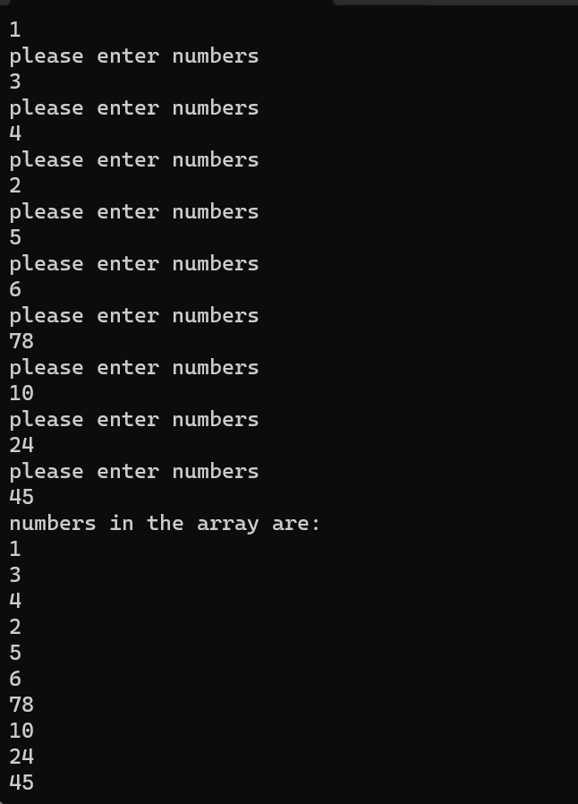

**Task 2**

int main(){

//declaration of array and variable

int num[5],sum,product,i,j;

sum=0;

product=1;

//using for loops to calculate sum and product of all elements for loop

for(i=0;i<5;i++)

{

cout<<"please enter numbers for the array"<<endl;

cin>>num[i] ;

sum=sum +num[i];

product=product*num[i];

}

//outputting sum and product

cout<<"sum and product of numbers in array is "<<sum<<" and "<<product;

}

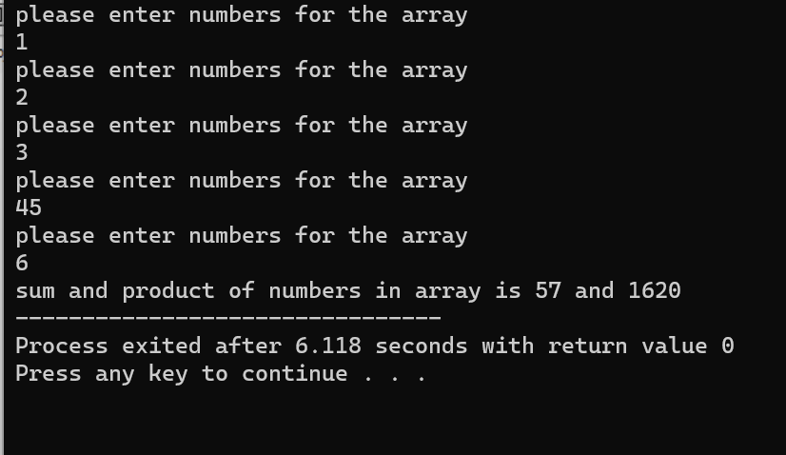

**Task 3**

int main(){

//declaration of variables

int n=7;

int half=n/2;

char diam[n];

for (int i=0;i<n;i++){

diam[i]=' ';

}

//making first half using for loops

for (int i=0;i<half;i++){

for(int j=0;j<n;j++){

diam[half+i]='*';

diam[half-i]='*';

cout<<diam[j];

}

cout<<endl;

}

//making second half

for(int a=half-1;a>=0;a=a-1){

for(int b=n;b>=0;b=b-1){

diam[half+a]=' ';

diam[half-a]=' ';

cout<<diam[b];

}

cout<<endl;

}

}

